New Event Request Form
Proposed Event Name: IRONMAN 5150 Asunción Paraguay
Proposed Regional Director:
Proposed Race Director:
Proposed Location: El Delta Nueva Asunción, Paraguay
Proposed Date: April 25, 2027
Provide a brief description of proposed event and why WTC should pursue it
The IRONMAN 5150 Asunción Paraguay is a strategic relocation of the existing IRONMAN 5150 Encarnación Paraguay to El Delta Nueva Asunción, positioned as the season-opener and build-up race for the IRONMAN 70.3 Asunción Paraguay (August 22, 2027). The relocation upgrades the event's positioning in capital-city access, international airport connectivity (Silvio Pettirossi), broader sponsor pool and institutional support (Marca País Paraguay).
Untapped Market & Growth Potential – This location serves as a prime market for endurance sports with an increasing number of triathletes and fitness enthusiasts. The 5150 Olympic distance captures the broader regional triathlon base — a more accessible distance that builds the regional triathlon community toward 70.3 participation.
Capital-City Access & International Connectivity – Asunción concentrates Paraguay's largest population and economic base. Silvio Pettirossi International Airport offers direct flights to Miami and regional hubs (Sao Paulo, Buenos Aires, Lima, Santiago) — enabling regional athlete recruitment that Encarnación could not deliver.
Premium Venue Partnership – El Delta Nueva Asunción participates as Official Venue + Official Sponsor under a proposed multi-year framework (2027/2028/2029). The venue partnership absorbs major production costs (Finish Line, VIP hospitality, audio production, venue site adaptation) under Bloque 1 of the alliance. Operational efficiency across both 5150 (April) and 70.3 (August) editions through equipment reuse.
Spectacular Course & Scenic Value – The proposed course offers a flat, fast circuit within and around the premium master-planned venue, ensuring a rewarding experience for athletes at the Olympic distance while maximizing media appeal.
Season-Opener & 70.3 Build-up – Sequenced 17-week training window between the 5150 (April 25) and the 70.3 (August 22) creates a coordinated Paraguay season for athletes pursuing both events. The 5150 also opens the regional Southern Cone triathlon calendar.
Economic & Financial Viability – Smaller operational footprint than the 70.3 (single-day event, ~1/3 of athlete volume) combined with the El Delta partnership cost absorption delivers strong unit economics from Year 1.
Community & Government Support – Local stakeholders, including Municipalidad de Asunción, Sports Secretariat of Paraguay, Tourism Ministry, and Marca País Paraguay endorsement, ensure seamless permitting, security, and operational efficiency.
Strategic Brand Expansion – Hosting the 5150 alongside the 70.3 in a single venue and a single year consolidates IRONMAN's portfolio in Paraguay, fostering brand loyalty and creating a development pathway from Olympic distance to 70.3.
With its compelling course, economic upside, and strategic positioning as season-opener and 70.3 build-up, the IRONMAN 5150 Asunción consolidates Paraguay's IRONMAN portfolio under a single premium venue.
Financial Considerations
Financial Impact to Company | Expected Profit Years 1 – 3 (from attached budget)
 | $ | $ |  | $
Please attach the budget for the event. In the space below, comment on the expected Financial Impact of the event attempting to address as many of the questions on the attached sheet as are relevant.
Required Investment | Initial Investment (attach detail) |  | IRR (from attached)
 | $ |  | %
Provide clarifying comments, if necessary.
Form of Arrangement | License | Acquire |  | Build
Comment on the decision relative to the form of the arrangement. Add any relevant information not addressed below including a comment as to what the license fee might be if licensing were selected and the availability of a competing race to buy.

Athlete Experience
 | 1 | 2 | 3 | 4 | 5
Quality of Swim Course |  |  |  |  | X
(Rank from 1 – 5 with ‘5’ representing the highest quality based on metrics provided in the attached)
- Water Type & Conditions – The 1.5km swim takes place in the Río Paraguay at the El Delta Nueva Asunción venue, providing a calm and controlled environment, especially in the morning hours.
Current & Tidal Impact – The Paraguay River segment near El Delta is not significantly affected by strong currents. Wind is not a typical factor in the morning window.
Weather Considerations – Sunday April 25, 2027 (Southern Hemisphere autumn transition): water temperature typically 22-24°C. Wetsuit-legal status to be confirmed against IRONMAN cutoff (typical 24.5°C threshold). Air temperature average 18-27°C.
Accessibility – Entry and exit points designed jointly with the El Delta venue site team for clean access and athlete flow.
Proximity to Transition Zone – Target less than 100m from swim-out to T1, following IRONMAN standards. Shorter 5150 event with faster rotation requires especially tight swim-to-T1 flow.
Conclusion
Stable autumn water, controlled river segment within a premium master-planned venue, and tight swim-to-T1 layout deliver an IRONMAN-standard 5150 swim course.
 | 1 | 2 | 3 | 4 | 5
Quality of Bike Course |  |  |  |  | X
(Rank from 1 – 5 with ‘5’ representing the highest quality based on metrics provided in the attached)
Course Structure & Distance – The 40km bike course consists of two laps of 20km in an out-and-back design within and around the El Delta Nueva Asunción venue, sharing the core route corridor with the 70.3 for operational efficiency.
Road Surface Quality – Asphalt across the proposed corridor is in excellent condition. El Delta venue is built with premium-standard road infrastructure. Both lanes will be closed for the event.
Elevation & Technical Challenge – Flat-and-fast profile — a key strategic advantage of the venue. Preliminary target ≤70m total elevation gain over both laps (proportional to the 140m target for the 70.3's 90km circuit).
Weather Considerations – April 25, 2027 (Southern Hemisphere autumn transition): low rainfall risk (~80mm monthly average, declining toward end of April), no significant meteorological phenomena recorded historically. Stable autumn conditions favor sustained bike effort.
Road Closures & Safety – Full closures coordinated with Policía Nacional, ANT (Agencia Nacional de Tránsito), Municipalidad de Asunción and Marca País Paraguay. El Delta as a controlled premium development zone simplifies internal circuit closures vs. open-city alternatives.
Conclusion
Flat, fast, fully-closed circuit on premium infrastructure in stable autumn conditions — an IRONMAN-standard 5150 bike course optimized for Olympic-distance performance.
 | 1 | 2 | 3 | 4 | 5
Quality of Run Course |  |  |  |  | X
(Rank from 1 – 5 with ‘5’ representing the highest quality based on metrics provided in the attached)
Course Structure & Surface – The 10km run course consists of two laps of 5km + finish segment within and around the El Delta Nueva Asunción venue. Premium development infrastructure — paved roads and pedestrian pathways in excellent condition.
Elevation & Challenge – Minimal elevation gain (target ≤30m total), enabling fast Olympic-distance times while remaining accessible to all athlete levels.
Weather Conditions – April 25, 2027: average temperatures 18-27°C, moderate humidity, low rainfall risk. Comfortable autumn conditions for the Olympic-distance run; start time optimized to leverage cooler morning conditions.
Accessibility & Road Closures – Full closure of run course routes. Internal venue pedestrian paths controlled by El Delta. External segments coordinated with Municipalidad and Policía Nacional.
Spectator Engagement – Layout integrated within the master-planned premium venue enables strong crowd presence at strategic points and finish line.
Conclusion
Flat, premium-surface 10km run on controlled venue infrastructure with favorable autumn weather — supports a premium athlete experience for the IRONMAN 5150 format.
 | 1 | 2 | 3 | 4 | 5
Quality of Transition |  |  |  |  | X
(Rank from 1 – 5 with ‘5’ representing the highest quality based on metrics provided in the attached)
Proximity & Layout – Double transition area, target <100m from swim exit to T1. El Delta master-planned venue layout enables an integrated swim-to-transition flow following IRONMAN standards. 5150 footprint materially more compact than the 70.3 (~1/3 of bike volume) — typical 5150 transition ~80m × 25m vs. 70.3's 130m × 35m.
Surface & Safety – Transition zone set on premium pavement standard infrastructure of the El Delta development.
Medical & Support Services – Dedicated medical team stationed within the transition area with direct access to the Asunción hospital network (Hospital Central IPS, Hospital del Trauma, Sanatorio Italiano, plus multiple specialized centers).
Accessibility & Logistics – El Delta venue provides ample space exceeding IRONMAN 5150 standard requirements. The El Delta alliance commits the venue to deliver finish line, VIP, audio production and venue adaptation to IRONMAN standards across both 5150 and 70.3 editions of the year.
Volunteer & Parking Support – El Delta venue includes dedicated parking infrastructure with capacity for volunteers and support staff.
Conclusion
Master-planned premium venue with double transition, strong medical backbone, and venue-partner committed infrastructure — one of the highest-quality 5150 transition setups.
 | 1 | 2 | 3 | 4 | 5
Quality of Finish Line |  |  |  |  | X
(Rank from 1 – 5 with ‘5’ representing the highest quality based on metrics provided in the attached)
Iconic Location & Atmosphere – Finish Line within the El Delta Nueva Asunción master-planned premium development — the most ambitious real estate development in Paraguay. Iconic backdrop integrated with premium architecture, delivering a high-energy visual experience. Same finish line infrastructure serves both 5150 and 70.3 across the calendar year.
Spectator Engagement – Premium venue designed with public spaces enabling strong spectator presence and high-visibility positioning.
Surface & Safety – Final stretch features premium development pavement standard, ensuring a smooth and safe sprint to the finish.
Space & Logistics – El Delta master plan provides ample space — comfortably exceeding 5150 finish line requirements. The El Delta alliance commits the venue to produce the Finish Line structure, arch, lighting, audio and full assembly to international IRONMAN standards.
Memorable Athlete Experience – Designed with the “wow” factor — premium master-planned venue + integrated branding + celebratory production = an unforgettable finish for each athlete, whether crossing the line at the 5150 in April or the 70.3 in August.
Conclusion
Premium master-planned venue + partner-produced Finish Line + capital-city positioning rank this setup among IRONMAN's top-tier 5150 race conclusions.
 | 1 | 2 | 3 | 4 | 5
Quality of Technical Functions / Areas |  |  |  |  | X
(Rank from 1 – 5 with ‘5’ representing the highest quality based on metrics provided in the attached)
- Spacious & Well-Organized Venue – El Delta Nueva Asunción is a master-planned premium real estate development with ample integrated space for technical operations, athlete services, and logistics. The 5150 is operationally more compact than the 70.3 (single-day event, smaller athlete cap).
Efficient Traffic & Community Management – Asunción metropolitan area has the strongest traffic management capacity in Paraguay (ANT, Policía Nacional national HQ). El Delta as a controlled premium development zone simplifies internal closures vs. open-city alternatives.
Safe & Structured Entrances/Egresses – Premium development infrastructure provides controlled, well-designed access points for athletes, staff and spectators.
Volunteer & Staff Infrastructure – Dedicated parking and access routes within the venue. Asunción offers a substantially broader volunteer pool than Encarnación (universities, sports federations, Sports Secretariat of Paraguay).
Fully Equipped Event Areas – Transition zones, aid stations, medical tents, expo and media spaces integrated within the master-planned venue under partner commitment to IRONMAN-standard fit-out. Equipment reuse between 5150 (April) and 70.3 (August) provides operational efficiency.
Conclusion
Premium master-planned venue with integrated event areas, strong institutional traffic backbone, and partner-committed fit-out — meets the highest IRONMAN 5150 technical standards.

Weather | 1 | 2 | 3 | 4 | 5
(Rank from 1 – 5 with ‘5’ representing the highest quality based on metrics provided in the attached) |  |  |  |  | X
Please comment on the likely weather attempting to address as many of the questions on the attached sheet as are relevant.
- Stable Climate Conditions – Sunday April 25, 2027 (Southern Hemisphere autumn transition): no significant meteorological concerns recorded historically for this window in Asunción.
Optimal Temperature Range – Average temperatures 18-27°C (64°F-81°F). Moderate humidity. Comfortable race conditions — warmer than the August 70.3 slot (12-25°C) but well within IRONMAN comfort range for the Olympic-distance format. Start time optimized to leverage cooler morning conditions.
Low Risk of Weather Disruptions – Low rainfall risk (~80mm monthly average, declining toward end of April). No records of extreme weather occurrences in this window.
Favorable Humidity & Wind Conditions – Stable autumn pattern supports consistent race-day performance for the 5150 distance.
Conclusion
Comfortable autumn window in Asunción — optimal athlete safety and performance conditions for the Olympic-distance 5150 format.
Intangibles | 1 | 2 | 3 | 4 | 5
(Rank from 1 – 5 with ‘5’ representing the highest quality based on metrics provided in the attached) |  |  |  |  | X
Please comment on the intangibles of hosting an event at this venue (e.g., branding, strategic value, etc.)
- Global Branding & Prestige – The 5150 Asunción consolidates IRONMAN's brand at the capital-city level alongside the 70.3, creating a unified IRONMAN portfolio in Paraguay across two editions per year. Marca País Paraguay endorsement positions the event as an official vehicle of Paraguay's international representation.
Strategic Regional Value – Asunción + Silvio Pettirossi International Airport unlock regional athlete recruitment (Buenos Aires, Sao Paulo, Lima, Santiago direct flights) — strengthening IRONMAN's footprint in South America at the Olympic distance.
Economic & Tourism Impact – Capital-city positioning + premium venue partnership amplify tourism impact. The 5150 captures a broader Olympic-distance segment with strong overlap into the 70.3 build-up market.
Long-Term Growth & Legacy – Sequenced 5150 + 70.3 calendar under a multi-year framework with El Delta (2027/2028 + option 2029) consolidates Asunción's identity as a premier endurance destination, with the 5150 acting as the development pathway into IRONMAN 70.3 participation.
Community Engagement & Social Impact – Sports Secretariat of Paraguay, Federación Paraguaya de Triatlón, universities and running event organizations active in Asunción provide strong volunteer and community engagement infrastructure across both 5150 and 70.3 editions.
Conclusion
Capital-city positioning + premium venue + sequenced 5150→70.3 portfolio + Marca País endorsement = a transformational upgrade for IRONMAN's Olympic-distance footprint in South America.

Technical Aspects
Ancillary Functions (Expo/Banquets/Village/Housing/Bussing) | 1 | 2 | 3 | 4 | 5
(Rank from 1 – 5 with ‘5’ representing the best situation based on metrics provided in the attached) |  |  |  |  | X
Please comment on the ancillary functions attempting to address as many of the questions on the attached sheet as are relevant.
Expo & Registration Space – Expo, registration and ancillary functions hosted at the El Delta Nueva Asunción venue itself, integrated with the master-planned premium infrastructure. Both indoor and outdoor weather-protected options available.
Athlete Housing & Accommodation – Asunción metropolitan area offers >15,000 hotel rooms across all categories, including premium international brands (Sheraton, Crowne Plaza, Esplendor, Yacht & Golf Club Paraguayo, Bourbon Conmebol). For the 5150 cap (600-1,500 atletas), accommodation capacity is more than sufficient and accessible across price points — well below saturation thresholds.
Bussing & Parking Accessibility – El Delta venue includes dedicated parking infrastructure. Shuttle services from key athlete accommodation hubs to the venue will be evaluated. Asunción metropolitan transport infrastructure is materially stronger than Encarnación.
Banquets & Village Experience – Multiple options for Welcome / Awards Banquet: on-site within El Delta venue (premium hospitality facilities), premium hotels in Asunción, or country clubs and convention centers in the metropolitan area.
Warehousing & Logistics – Warehousing options: (a) on-site secure space within El Delta venue, (b) our own trucks, (c) permanent warehouse in Asunción 20 minutes from the race venue. Equipment reuse between 5150 (April) and 70.3 (August) provides operational efficiency.
Conclusion
Premium master-planned venue with integrated expo, ample premium accommodation in Asunción, partner-controlled venue access, and own warehousing infrastructure — top-tier ancillary setup for IRONMAN 5150.
Community / Political Climate | 1 | 2 | 3 | 4 | 5
(Rank from 1 – 5 with ‘5’ representing the best situation based on metrics provided in the attached) |  |  |  |  | X
Please comment on the Community / Political Climate attempting to address as many of the questions on the attached sheet as are relevant.
Strong Community Support – Marca País Paraguay endorsement granted at the national level positions the event as an official vehicle of Paraguay's international representation. Coordination structure: Municipalidad de Asunción, Sports Secretariat of Paraguay, Tourism Ministry, Marca País.
Traffic & Public Impact Management – El Delta is a controlled premium development zone — internal circuit closures are operationally simpler than open-city alternatives. External route segments coordinated with Policía Nacional, ANT (Agencia Nacional de Tránsito) and Municipalidad de Asunción.
Public Perception & Acceptance – Asunción has actively positioned the city as international event destination. Recent track record: ODESUR South American Games (2022), World Rally Tour Paraguay 2025, regional football tournaments, multiple international marathons.
Political & Governmental Stability – Asunción municipality is stable and committed to international events positioning. Marca País Paraguay endorsement is a national-level commitment that transcends municipal political cycles.
Legacy & Strategic Growth – Capital-city + premium master-planned venue + sequenced 5150→70.3 portfolio = transformational positioning for IRONMAN's South American footprint, with multi-year alliance ensuring continuity.
Conclusion
Strongest institutional + community backing achievable in Paraguay — Marca País endorsement, capital-city government, premium venue partner, demonstrated track record in international sporting events.
Personnel | 1 | 2 | 3 | 4 | 5
(Rank from 1 – 5 with ‘5’ representing the best situation based on metrics provided in the attached) |  |  |  |  | X
Please comment on the staffing attempting to address as many of the questions on the attached sheet as are relevant.
Experienced & Capable Team – Core Rebelocity team from Encarnación 2025/2026 transfers to Asunción setup. Rebelocity is the Official IRONMAN Licensee for Paraguay with demonstrated operational delivery capability across the IRONMAN distance portfolio (5150 and 70.3).
Strong Volunteer Leadership – Alliances active with Federación Paraguaya de Triatlón, running event organizations, universities in Asunción metropolitan area, and the Sports Secretariat of Paraguay — substantially broader volunteer pool than Encarnación.
Medical & Safety Personnel – Asunción metropolitan area has the most extensive hospital and emergency network in Paraguay: Hospital Central IPS, Hospital de Clínicas (UNA), Hospital del Trauma, Sanatorio Italiano, Sanatorio San Roque, plus multiple specialized centers. Dedicated medical team stationed at key points. 5150's shorter distances require tighter rescue coverage — manageable with this network.
Logistics & Road Management – Coordination with Policía Nacional and ANT (Agencia Nacional de Tránsito) — both headquartered in Asunción.
Comprehensive Volunteer Support – Strong volunteer base from prior events, with broader recruitment pool in Asunción.
Conclusion
Experienced licensee team + materially broader volunteer and medical infrastructure in Asunción = staffing capability that fully meets IRONMAN 5150 international standards.

Athlete Assumptions
Risk of cannibalization, Athlete Count, etc. | 1 | 2 | 3 | 4 | 5
(Rank from 1 – 5 with ‘5’ representing the lowest risk based on metrics provided in the attached) |  |  |  |  | X
Please comment on the Athlete Assumptions attempting to address as many of the questions on the attached sheet as are relevant.
Low Risk of Market Cannibalization – The 5150 Asunción and 70.3 Asunción (August 22, 2027) target the same athlete base at different points of the training cycle — complementary, not cannibalizing. The 5150 is positioned as season-opener and build-up race for the 70.3. The local Paraguayan triathlon market is underserved at the Olympic distance.
Strong Athlete Demand – Capital-city access + Silvio Pettirossi International Airport (Miami direct, regional hubs Sao Paulo / Buenos Aires / Lima / Santiago) materially expand the addressable athlete market. The 5150 distance has stronger appeal to the regional Olympic-distance base than the 70.3, opening recruitment to a younger, multi-discipline crossover profile.
Athlete Targets – Year 1 (2027) target: 600 atletas. Conservative downside: 400 atletas in Year 1. Mature trajectory: 1,000 atletas by Year 3.
Strategic Course Design – Double transition area with target <100m from swim exit to T1. Flat, fast Olympic-distance course profile maximizes athlete experience.
Emergency & Medical Access – One ambulance per turn point. Direct access to Asunción hospital network (Hospital Central IPS, Hospital del Trauma, Sanatorio Italiano).
Clear Communication & Logistics – El Delta partnership delivers complete audio system, sound and announcing for the event and route.
Conclusion
Upgraded venue + larger addressable athlete market + premium medical and operational backbone + sequenced calendar with the 70.3 = minimal cannibalization risk and materially higher athlete participation potential vs. Encarnación.
Other Considerations
Growth Potential & Long-Term Athlete Engagement – Sequenced calendar (5150 Asunción April 25, 2027 → 70.3 Asunción August 22, 2027) creates a coordinated Paraguay season — 17 weeks of training window between events, ideal for athletes pursuing both as a season plan. The 5150 serves as the development pathway into 70.3 participation.
Inclusivity & Athlete Diversity – Olympic-distance accessibility broadens the addressable market (first-time triathletes, age-group racers, multi-sport crossover athletes) and unlocks regional athlete recruitment from the Cono Sur.
Impact on Local & Regional Sports Development – El Delta Nueva Asunción as Official Venue creates a year-round endurance destination — pre-race activations, clinics and content within the venue across the 12 months prior to race day, leveraged by both 5150 and 70.3.
Sponsorship & Athlete Incentives – Multi-year framework with El Delta (2027/2028/2029) plus title sponsor ueno bank under renewal. A broader corporate base in Asunción enables sponsorship partnerships with athlete perks (training support, discounted entry, travel assistance for top performers).
Post-Race Experience & Community Integration – Premium venue + Marca País endorsement + capital-city positioning enable post-race programs (training camps, school outreach, wellness initiatives) at materially larger scale than Encarnación.
Conclusion
Coordinated 5150 + 70.3 Paraguay season + premium venue + capital-city base = strongest long-term athlete engagement and legacy positioning available for IRONMAN's Olympic-distance footprint in the country.

OVERALL RATING
 | 1 | 2 | 3 | 4 | 5
 | ☐ | ☐ | ☐ | ☐ | ☐

Actions:
# | Action Item | Assigned To | Due By
 |  |  | [mm/dd/yyyy]
 |  |  | [mm/dd/yyyy]
 |  |  | [mm/dd/yyyy]
Approvals:
I approve the recommended course of action relative to this event.

WTC CEO: ___________________________ Date: ___/___/____

WTC COO: ___________________________ Date: ___/___/____

WTC CFO: ___________________________ Date: ___/___/____

Regional MD: ___________________________ Date: ___/___/____

Regional Head of Ops: ___________________________ Date: ___/___/____

Regional Head of Finance: ___________________________ Date: ___/___/____

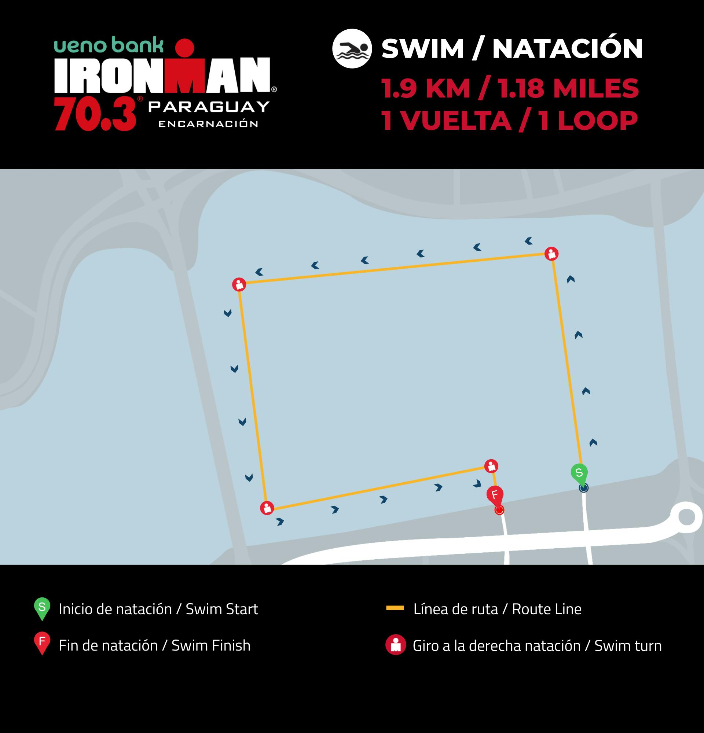

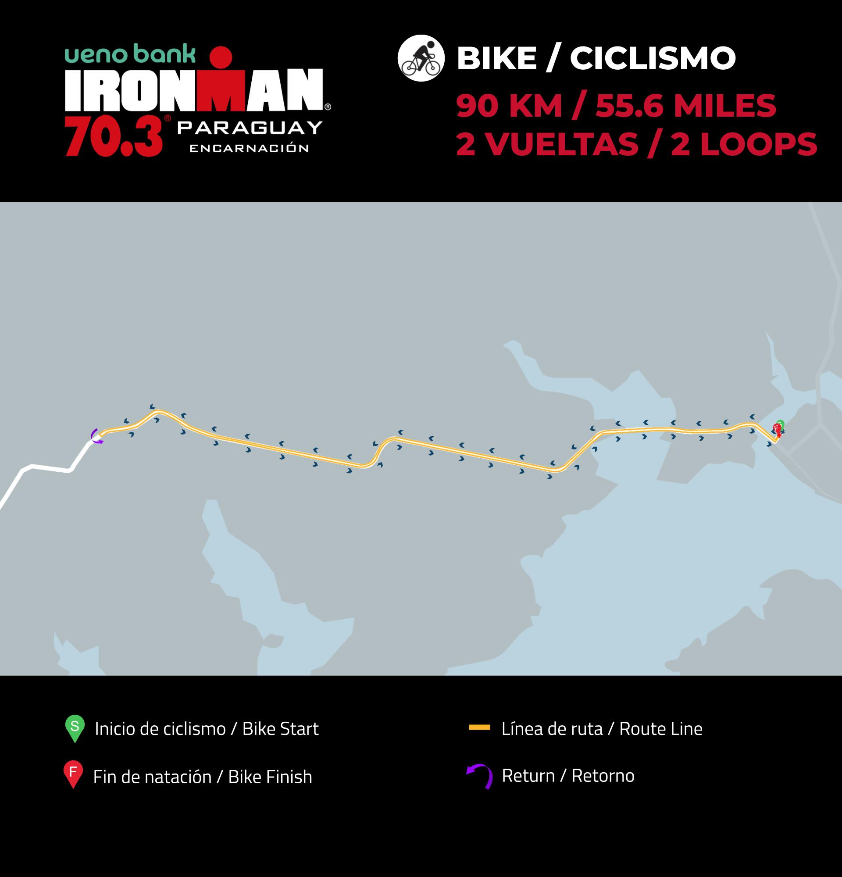

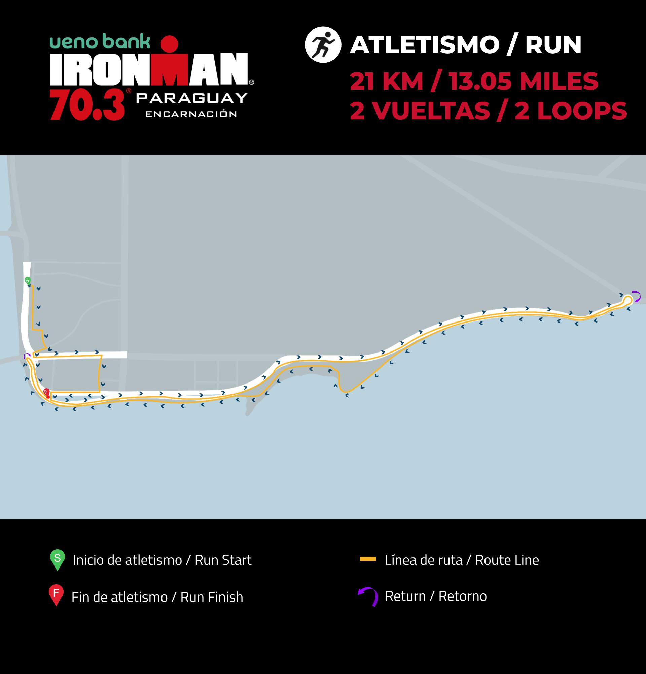

CIRCUITO NATACIÓN 1,5 KM

CIRCUITO CICLISMO 40 KM

CIRCUITO CARRERA 10 KM

